CSA05-DATABASE MANAGEMENT SYSTEMS

EXP-01

DDL Commands – CREATE, ALTER, DROP

AIM:
To Create, Alter, Drop, Rename, Truncate using Data Definition Language (DDL) statements. Description:
Data Definition Language (DDL) statements are used to define the database structure or schema. DDL Commands: Create, Alter, Drop, Rename, Truncate
    - CREATE - to create objects in the database
    - ALTER - alters the structure of the database
    - DROP - delete objects from the database
    - TRUNCATE - remove all records from a table, including all spaces allocated for the records are removed
    - RENAME - rename an object

PROCEDURE:
- Open MySQL Workbench and connect to the MySQL server.
- Select the bank database using:
USE bank;
- Create the BANKRECORDS table using the CREATE TABLE command.
- Execute the command using the Execute (⚡) button.
- Verify the table structure using:
DESC BankRecords;
- Create the other banking tables — ACCOUNT, BRANCH, and TRANSACTION — using CREATE TABLE.
- Modify the table structure using ALTER TABLE commands.
- Verify the modified structure using DESC table_name.
- Perform other DDL operations such as DROP, RENAME, and TRUNCATE as required.
- Observe and record the output displayed in MySQL Workbench.

SYNTAX:
CREATE TABLE
CREATE TABLE table_name
(
column_name1 data_type,
column_name2 data_type,
column_name3 data_type,
....
);
ALTER A TABLE
To add a column in a table
ALTER TABLE table_name
ADD column_name datatype;
To delete a column in a table
ALTER TABLE table_name
DROP COLUMN column_name;
DROP TABLE
DROP TABLE table_name
TRUNCATE TABLE
TRUNCATE TABLE table_name;

QUESTIONS:
- Create a table name BANKRECORDS with the following structure.
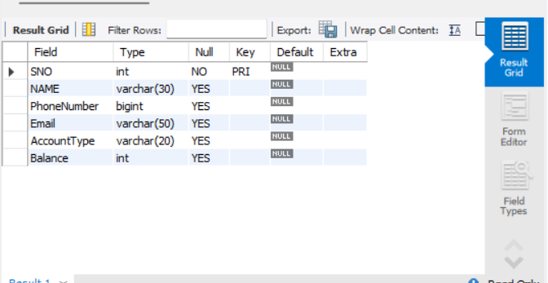
2)Create a table name ACCOUNT with the following structure.
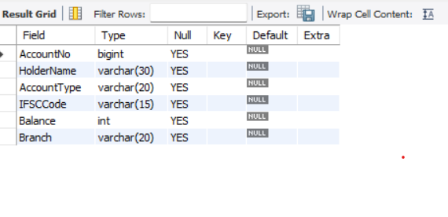

3) Create a table name BRANCH with the following structure.
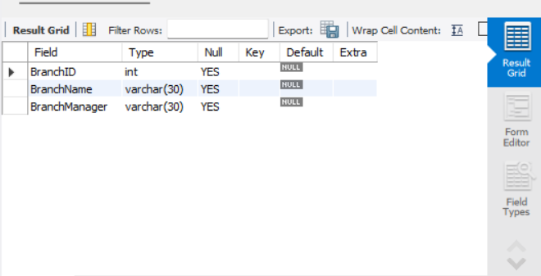

4) Create a table name TRANSACTION with the following str ucture.

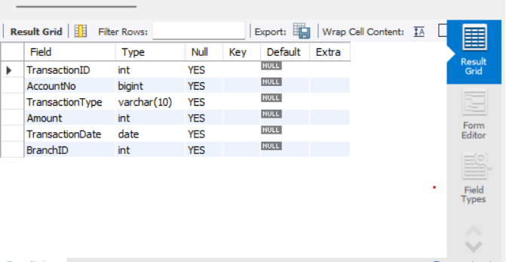
5)Modify the table ACCOUNT by adding a column name Dept of datatype VARCHAR(10).
QUEUE:
OUTPUT:
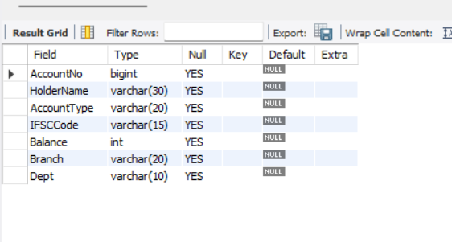

RESULT:
Tables are created, altered and modified using DDL commands

